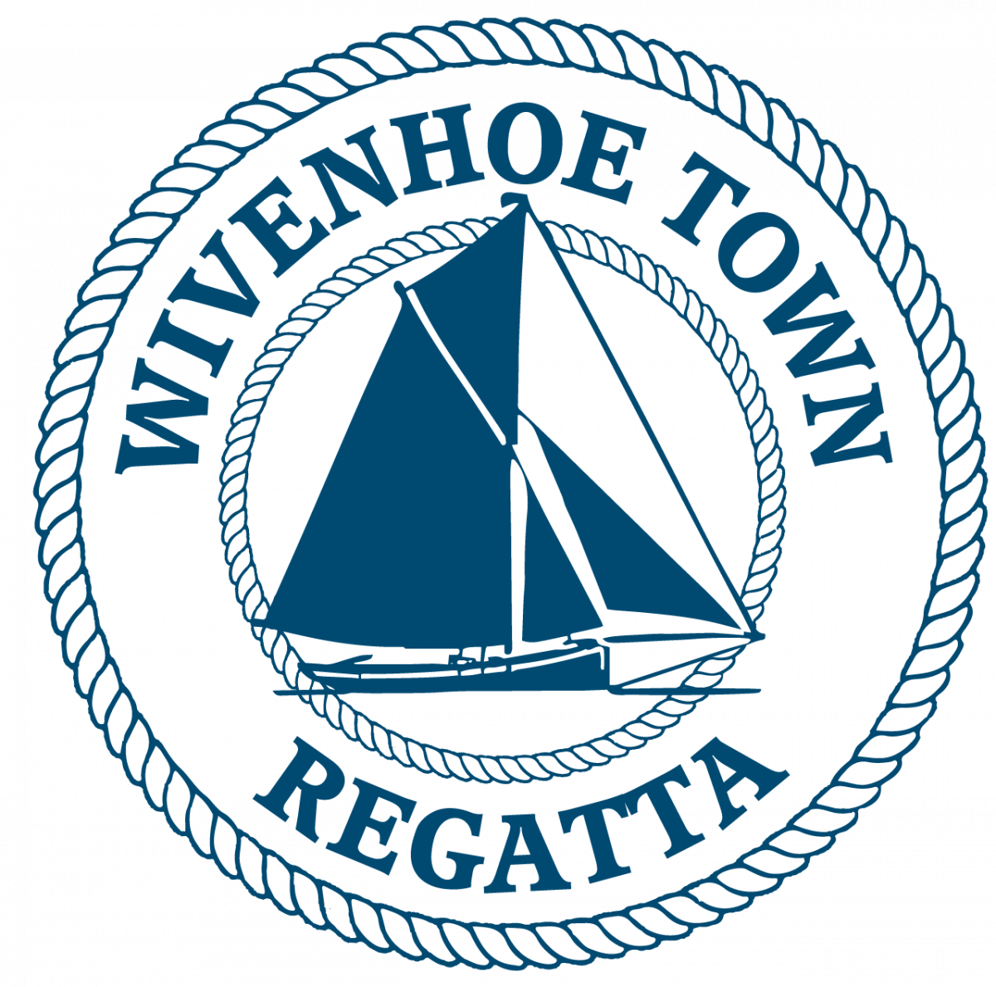
WIVENHOE TOWN REGATTA
SMACK RACE 2025

SATURDAY 12th July 2025
HW WIVENHOE 1420 BST
Sailing Instructions

N.B. Interaction between vessels in different races in the Regatta shall be governed by the International Regulations for the Prevention of Collisions at Sea. (IRPCS)

The Smack race will start off Batemans Tower at 1045, and finish at Wivenhoe at approximately 1300.

START TIMES Full Batemans Tower Start Schedule:
1045 Smacks
1105 Yachts,
1125 Classic Yachts and Gaffers
1145 BODs
Each race will have its own start sequence and course number displayed before its start.

RACE OFFICER
The Race Officers will work from Batemans Tower. They will listen out on VHF 77 from 1015 and the Smack’s Race course will be announced on VHF 77 around 1025. The course number will also be displayed on a board at Batemans Tower at 1025.
The Race Officer may be contacted on VHF channel 77 before the start sequence.

The race shall be governed by the current version of the Racing Rules of Sailing (RRS).
N.B. Interaction between vessels in different races in the Regatta shall be governed by the International Regulations for the Prevention of Collisions at Sea.

INSURANCE
Each participating boat shall be insured with valid third party liability insurance with a minimum cover of £2,000,000 per event or the equivalent.

START LINE
Between Batemans Tower & the triangular metes on the E Mersea shore.

STARTING 5 Minutes: Horn + Code flag C 
4 minutes: Horn + Blue Peter
1 minute : Long horn + Blue peter lowered
START: Horn + Code flag C lowered
If a vessel is over the line at the start a second horn will sound and one flag will be raised and stay hoisted until that offender has re-crossed the line.

COURSES: SUITABLE WINDS

1. Bar- S, BH- S, IBH- P, No12- P, No 8- S, Finish Line Wivenhoe.(13 NM) NW-SW,
NE-SE. F3-4
2. No 8- S, No12- S, No 8- S, Finish line Wivenhoe..…………………(7 NM) Light Airs

3. IBH- S, No12- P, No 8- S, Finish line Wivenhoe ... (9 NM) Nly. F2-3

4. IBH- S, No19- S, IBH- S, Finish line Wivenhoe..............(14 NM) W-SW, E-SE. F4-5

5. BH- P, Bar- P, IBH- P, BH- S, Finish line Wivenhoe(12 NM) Anything but N or E. F3-5

6. A course announced on VHF Ch. 77

NB ALL COURSES - OBSERVE ALL NAVIGATION MARKS UPRIVER FROM BUOY No 22 TO WIVENHOE FINISH LINE (Across the river at the WSC Old Hut 300 metres upstream of the Barrier). No vessels will be timed in after 14 15.

EVENTS ON THE RIVER ABOVE WIVENHOE SAILING CLUB
If there are other races going on when you arrive, be aware that all other racers have been advised not to impede your passage and to give you a wide berth. This should give you the maximum space for your final run through the Barrier and to the finish line but note the IRPCS apply to interaction with other vessels not in your race.

ENTRIES
Entry Forms are available on the Wivenhoe Town Regatta Website or call 07967 505854 or email: berniehetherington@gmail.com. Very late entries may be accepted via VHF ch77 on the day by the Race Officer before1000.

Rig & Sail Rules
To maintain the rules regarding working sail and traditional rig that have been set over the past years of running the event we consider that the spectacle of your historic
craft should continue to be protected against the use of non-traditional sails and rigs, in particular excessive headsails, and yacht spinnakers.
The points made below are aimed at providing common sense rules, to prevent
such infringements and maintain the spirit and flavour of a traditional working
boat race.
Number of Sails – A maximum of four working sails – mainsail, staysail, Jib and
either topsail or water sail set under the boom. Number of Sails – A maximum of four working sails – mainsail, staysail, Jib and either topsail or water sail set under the boom.
The Staysail – Can be either a normal working sail or a reaching staysail but
must remain fully hanked to the main forestay when in use.
The Jib – Must be set from the Bowsprit end to the mast head, not the top mast
head. The clew of the jib must not reach more than halfway between the stemhead and the mast.
Booming out – This is acceptable but the staysail must remain fully hanked to the main forestay.

MOORINGS
Temporary berths are available alongside the wall along West Quay upriver of the finishing line on a first come first served basis for competing smacks and yachts. The WSC launch Viking will be standing by and will be available to help and to ferry crews.

PRIZEGIVING AND SHORE EVENTS
Crew tokens will be available from the Old WSC Hut on the old hard for a free pint from the WSC hut on the old hard and a burger from the BBQ stall outside the Old Hard.
Prizegiving will take place outside the Old Hard Hut as soon as possible after the end of the race programme at 1400 approx. Timings will be confirmed on the day.

The race entry fee is £15 per vessel.

Profits from the Regatta will go to local charities & community groups

Please use BACS to transfer the £15 to the account below (or pay on the day
at the Old WSC hut).
Wivenhoe Town Regatta Sort code – 60-06-06 Account number – 32429592

Please Note Entry forms are available on the Wivenhoe Town Regatta Website
By returning a completed printed or emailed entry form you are agreeing to abide by the sailing instructions.

Sailing Smack Entry Form
Please apply early & send your entry form to berniehetherington@gmail.com

By signing the entry form entrants also confirm that they have read the statement below and will abide by those terms and conditions-:

1. Skippers/competitors/entrants joining a regatta race indicate that they accept full responsibility for the decision to race, and that the Wivenhoe Town Regatta Committee is not responsible for injury to crew or others, nor damage to their vessel or other vessels, resulting from taking part.
2.They confirm that they have valid third-party liability insurance of not less than £2m.
3. The skipper accepts that it is their responsibility to ensure the safety of the crew, and that the crew is provided with lifejackets and other appropriate safety equipment.
4. Skippers must be aware of the Racing Rules of Sailing which, in the event of a dispute between competitors during the race, will be interpreted in the spirit of Regatta Racing.
5. Skippers are reminded that when in the vicinity of any vessels not competing in their race, the International Rules for the Prevention of Collisions at Sea will apply.

Smack name: Date built:

Name of builder Place of Build

LOD: Draft: Reg No: Hull Colour:

Owner’s & Skipper’s Names:

Contact Address Contact Mobile tel no:
Contact Email address:

Number of crew on board:

Signed Print Name

(For any other questions please email Bernie Hetherington: berniehetherington@gmail.com or call 07967 505854)

