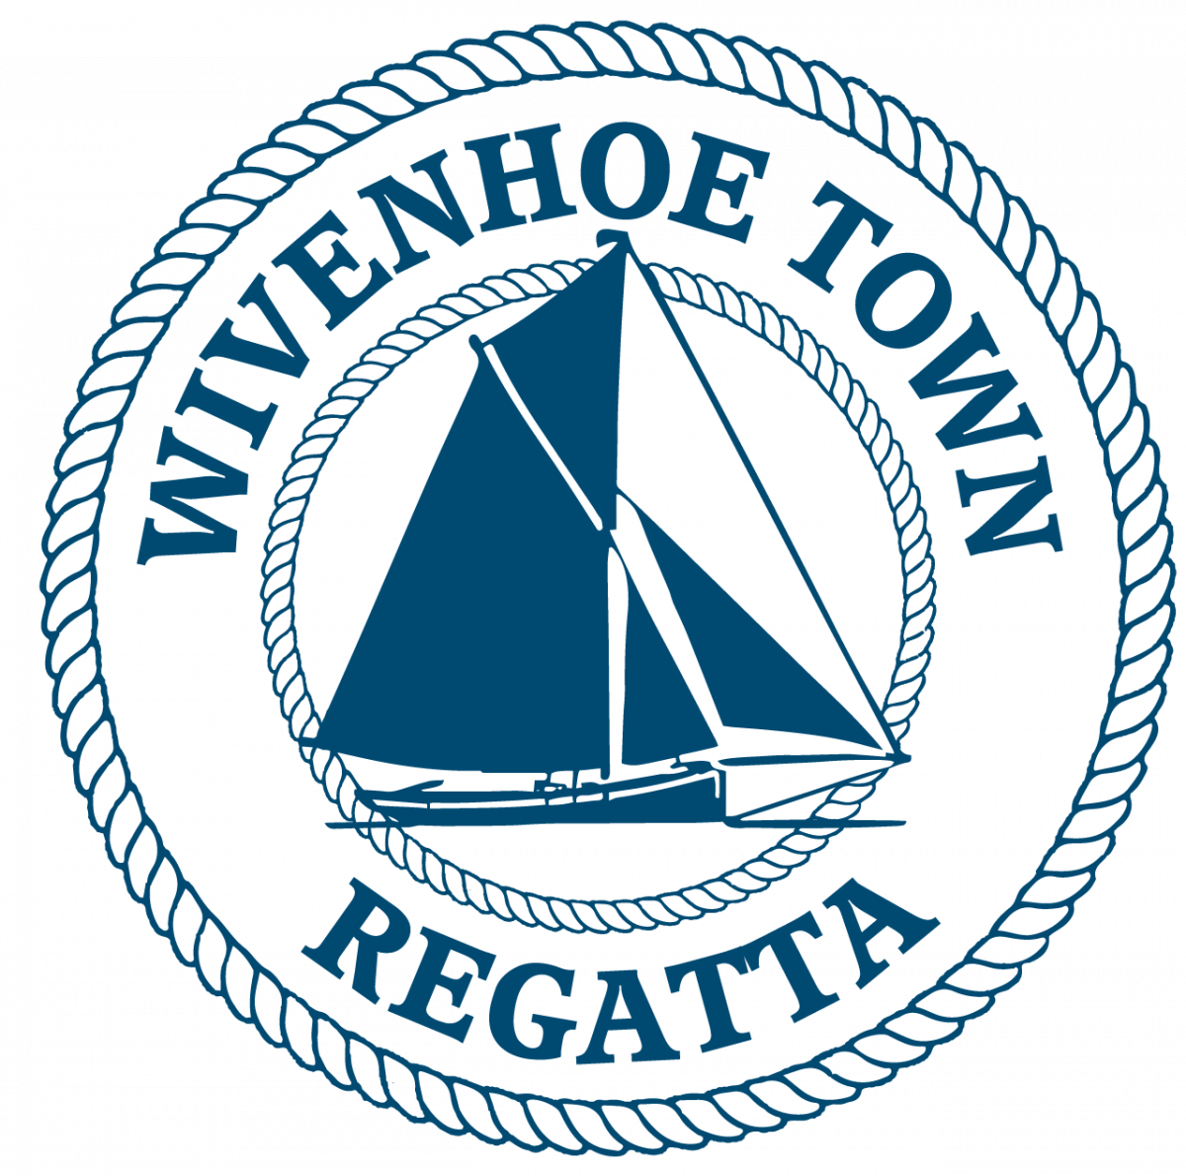
WIVENHOE TOWN REGATTA
BOD RACE

SATURDAY 12th July 2025
HW WIVENHOE 1420

Sailing Instructions

The BOD Race will start off Batemans Tower at 1145 and finish at Wivenhoe at 1300 approx. Full Batemans Tower Start Schedule:
1045 Smacks
1105 Modern Yachts
1125 Classic Yachts and Gaffers
1145 BODs
Each Race will have its own start sequence and course number displayed before its start. Note: No vessels will be timed in after 1430
RACE OFFICER
The Race Officers will work from Batemans Tower. They will listen out on VHF channel 77 from 1015.
The course number will be displayed on a board at Batemans at 1130
The Race Officer may be contacted on VHF channel 77 before the start sequence.

The race shall be governed by the current version of the World Sailing Racing Rules of Sailing (RRS).

N.B. Interaction between vessels in different races in the Regatta shall be governed by the International Regulations for the Prevention of Collisions at Sea. It is strongly recommended that crews of smaller and more manoeuvrable vessels do not impede the passage of the Sailing Smacks and larger yachts.

INSURANCE
Each participating boat shall be insured with valid third party liability insurance with a minimum cover of £2,000,000 per event or the equivalent.

START LINE: Between Batemans Tower & the triangular metes on the E Mersea shore.
STARTING: 5 minutes: Horn + Code flag C 
4 minutes: Horn + Blue Peter
1 minute : Long horn + Blue peter lowered
START: Horn + Code flag C lowered

If a BOD is over the line at the start a second horn will sound and one flag will be raised and stay hoisted until that offender has re-crossed the line.

COURSES:
“Down” = downriver start. “Up” = upriver start. “Ckm”= Creekmouth buoy
Even number buoys are red. Odd number buoys are green. s = leave to Std. p = leave to Port.

1. (Down): 9 s, 8 s, Ckm p, 12 s, 18 s, 12 s, Finish.
2. (Down): 9 s, 12 s, 16 s, 12 s, Finish.
3. (Up): 17 p, 12 s, 24 s, 16 s, Finish.
4. (Up): 17 p, 12 s, 24 s, 16 s, 24 s, 19 s, Finish.
5. (Up): 17 p, 8 p, 9 p, 17 p, 12 s, 24 s, 20 s, Finish.
6. (Up): 16 p, 12 p, Finish.

FINISH: A line across the river 300 metres upstream of the barrier at the WSC Old Hut. No vessels will be timed in after 1430.

MOORINGS: BODs may be tied up on moorings near the Hard at the new sailing club if space is available. Please do not land your BOD on the Hard as it will be full of rowing dinghies and rowers. The WSC workboat “Viking” will be available to help or to ferry crews.

PRIZEGIVING AND SHORE EVENTS
Crew tokens will be available from the old sailing club hut on the old hard for a beer/lager/ soft drink from the Old Sailing Club Hut on the old hard and a burger / sausage from the Regatta BBQ bar in front of the Old Hut after the race.
Prizegiving will take place outside the Old Sailing Club Hut and Hard as soon as possible after the end of the race programme. Timings will be confirmed on the day.

SPREAD THE WORD. HAVE A CRACKING SAIL AND ENJOY THE DAY.

The race entry fee is £10 per vessel & includes burger ‘n’ beer for crews.

Profits from the regatta will go to local charities & community groups

Please use BACS to transfer the £10 to the account below.
Wivenhoe Town Regatta
Sort code – 60-06-06 Account number – 32429592

ENTRIES Closing date for entries is 10/7/2025. Late entries may be accepted before 1000 on race day & pay at the old WSC sailing club hut.
Please Note. Entry forms are available on the Wivenhoe Town Regatta Website.
By returning a completed printed or emailed entry form, you are agreeing to abide by the sailing instructions.
Please email completed entry form to berniehetherington@gmail.com.
...........................................................................................................................

BOD RACE ENTRY FORM
By signing the entry form entrants also confirm that they have read the statement below and will abide by those terms and conditions-:

1. Skippers/competitors/entrants joining a regatta race indicate that they accept full responsibility for the decision to race, and that the Wivenhoe Town Regatta Committee is not responsible for injury to crew or others, nor damage to their vessel or others’ vessels, resulting from taking part.
2.They confirm that they have valid third-party liability insurance of not less than £2m.
3. The skipper accepts that it is their responsibility to ensure the safety of the crew, and that the crew is provided with lifejackets and other appropriate safety equipment.
4. Skippers must be aware of the Racing Rules of Sailing which, in the event of a dispute between competitors during the race, will be interpreted in the spirit of Regatta Racing.
5. Skippers are reminded that when in the vicinity of any vessels not competing in their race, the International Rules for the Prevention of Collisions at Sea will apply.

Boat name: Builder:

Sail No: Hull colour: Date Built:

Crew Names:

Contact Tel no:

Contact Address:

Contact Email address:

Any interesting history for the commentator?

Signed Print Name

