WIVENHOE TOWN REGATTA
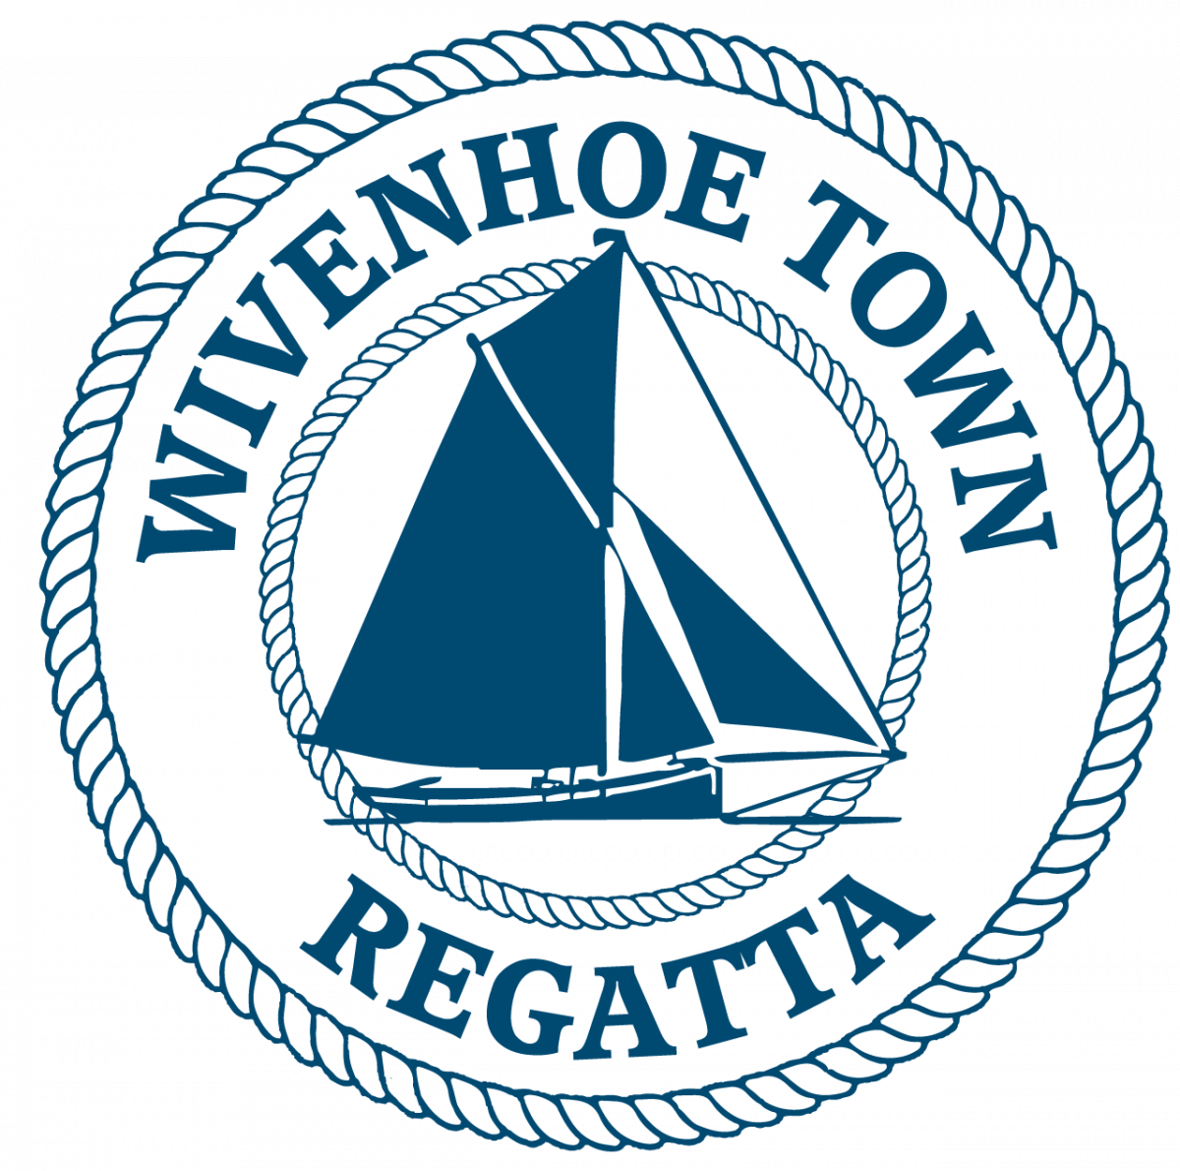
MODERN YACHT RACE SATURDAY 12th July 2025
HW WIVENHOE 1420 BST

The race for Modern Yachts will start off Batemans Tower at 1105 and finish at Wivenhoe at 1300 approx.
Sailing Instructions & Event Details

START TIMES Full Batemans Tower Start Schedule:
1045 Smacks
1105 Modern Yachts
1125 Classic Yachts and Gaffers
1145 BODs
Each Race will have its own start sequence and course number displayed before its start.

RACE OFFICER
The Race Officers will work from Batemans Tower. They will listen out on VHF 77 from1015 and the Yacht Race course will be announced on VHF 77 at 1050. The course number will also be displayed on a board at Batemans at 1050.
The Race officer may be contacted before the start on VHF channel 77.

The race shall be governed by the current version of the World Sailing Racing Rules of Sailing (RRS)

N.B. Interaction between vessels in different races in the Regatta shall be governed by the International Regulations for the Prevention of Collisions at Sea.
It is strongly recommended that crews of smaller and more manoeuvrable vessels do not impede the passage of the Sailing Smacks and larger yachts.

INSURANCE
Each participating boat shall be insured with valid third party liability insurance with a minimum cover of £2,000,000 per event or the equivalent.

START LINE
Between Batemans Tower & the triangular metes on the E Mersea shore.

STARTING: 5 minutes: Horn + Code flag C 
4 minutes: Horn + Blue Peter
1 minute: Long horn + Blue peter lowered
START: Horn + Code flag C lowered

If a vessel is over the line at the start a second horn will sound and one flag will be raised and stay hoisted until that offender has re-crossed the line.

COURSES FOR SLOW AND FAST HANDICAP RACES SUITABLE WINDS

All vessels racing should obey all navigation marks upriver from Buoy No 15 to Wivenhoe

1. Bar- S, Finish……………………………………………….(7·6 NM) Light Airs

2. Bar – P, Eagle – S, BH – S, IBH - P, Finish………….(10.5 NM) NW-SW, NE-E F3

3. Colne Point - S, No12- P, No 8- S, Finish……..…...(8·2 NM) Nly, S/SE F2-3

4. Bar – P, Wallet Spitway – P, Bar - S, Finish………......(16·4 NM) Good breeze, no tacking

5. Bar - P, Knoll – P, North Eagle – P, Bar – S, Finish……(11·5 NM) SW F 2-3

6. A course given over the VHF radio by the race officer.

{ BH = Bench Head. IBH = Inner Bench Head. }

FINISH
A line across the river from the old hard hut 300 metres upstream of the Barrier. Note: No vessels will be timed in after 1430.

Please be aware that the Smacks Modern Yachts, Classic Yachts, Gaffers & BODs will be racing through the Barrier to finish at the Old WSC line 300 yards beyond it. There may also be dinghy and Gig races still in progress. It is strongly recommended that smaller manoeuvrable vessels do not impede the passage of sailing smacks and large yachts.

HANDICAP SYSTEM
The handicaps used will be those issued by CYC.

MOORINGS
Please pick up a free mooring if available, there may also be space on the pontoons at the new WSC club house. You might also be able to lay alongside the wall along West Quay. There will be a blue launch named Viking available to help and to ferry crews.

PRIZEGIVING AND SHORE EVENTS
Prizegiving will be held in front of the old hard hut as soon as possible after the sailing race programme has ended at 1400 approximately. Crew tokens will be available from the old sailing club hut on the old hard for a free pint from the old sailing club hut on the old hard and a burger from the Rose & Crown BBQ after the race.

ENTRIES
Closing date for entries is 10/7/2025. Forms are available on the Wivenhoe Town Regatta Website or ring 07967 505854 or
email berniehetherington@gmail.comrace
Very late entries may be accepted via VHF 77 up to 1000 on race day by the Race Officer.

PLEASE SPREAD THE WORD!
HAVE A CRACKING SAIL AND ENJOY THE DAY.

The race entry fee is £15 per vessel.

Profits from the Regatta will go to local charities & community groups

Crew tokens will be available from the old sailing club hut on the old hard for a free pint from the old sailing club hut on the old hard and a burger from the BBQ by the British Legion after the race.

Free berths alongside West Quay or moorings in the river will be available and it's hoped that many racing craft will stay for the afternoon.

Please use BACS to transfer the £15 to the account below.
Wivenhoe Town Regatta
Sort code – 60-06-06 Account number – 32429592
Or pay on the day at the old sailing club hut.

For further details before the day email berniehetherington@gmail.com or telephone 07967505854.

Please Note Sailing Instructions and entry forms are available on the Wivenhoe Town Regatta Website. By returning a completed printed or emailed entry form you are agreeing to abide by the sailing and race entry instructions.

Please return your completed entry form by email to berniehetherington@gmail.com

MODERN YACHT RACE ENTRY FORM
By signing the entry form entrants also confirm that they have read the statement below and will abide by those terms and conditions-:
1. Skippers/competitors/entrants joining a regatta race indicate that they accept full responsibility for the decision to race, and that the Wivenhoe Town Regatta Committee is not responsible for injury to crew or others, nor damage to their vessel or others’ vessels, resulting from taking part.
2.They confirm that they have valid third-party liability insurance of not less than £2m.
3. The skipper accepts that it is their responsibility to ensure the safety of the crew, and that the crew is provided with lifejackets and other appropriate safety equipment.
4. Skippers must be aware of the Racing Rules of Sailing which, in the event of a dispute between competitors during the race, will be interpreted in the spirit of Regatta Racing.
5. Skippers are reminded that when in the vicinity of any vessels not competing in their race, the International Rules for the Prevention of Collisions at Sea will apply.

Yacht name: Class:

LOA: LWL: Beam: Draft:
Sail No: Handicap No: Keel Type:

Hull colour: Sail Colour: Rig:

Owners Name: Number of Crew onboard

Address: Mobile tel no:
Email address:

Signed Print Name

