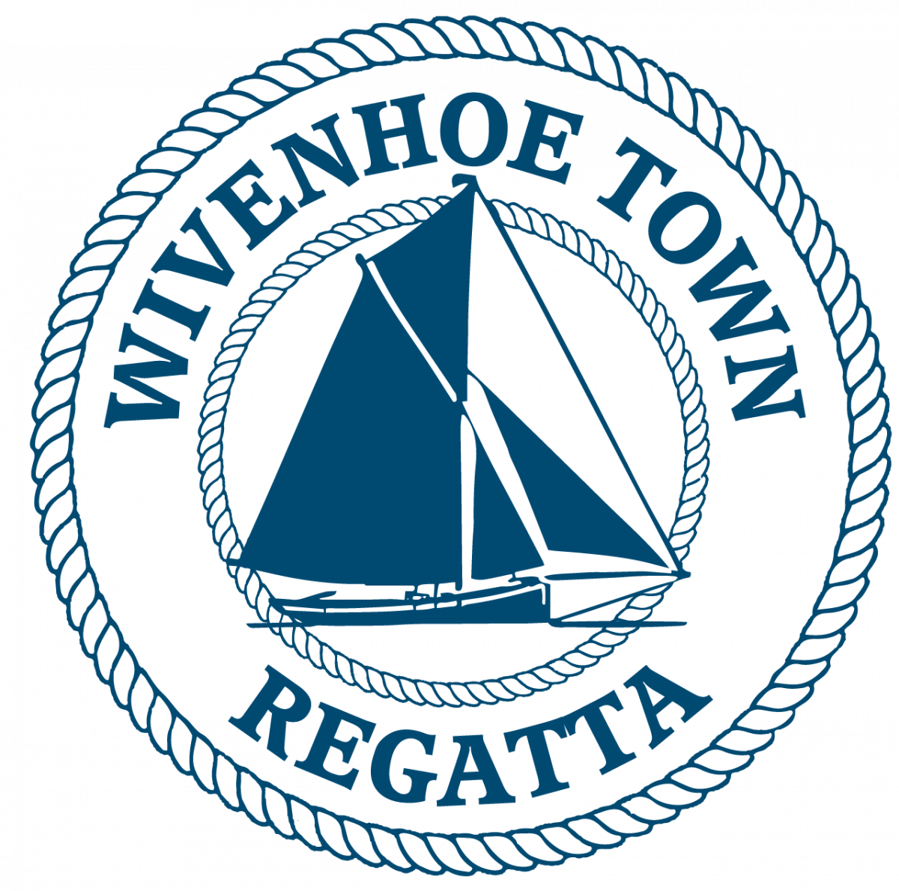
WIVENHOE TOWN REGATTA
WIVENHOE ONE DESIGN (WOD) Race

SATURDAY 12th July 2025
HW WIVENHOE 1420

SAILING INSTRUCTIONS & EVENT DETAILS

N.B. Interaction between vessels in different races in the Regatta shall be governed by the International Regulations for the Prevention of Collisions at Sea. (IRPCS)

INSURANCE
Each participating boat shall be insured with valid third party liability insurance with a minimum of £2,000,000 per event.

The race shall be governed by the current version of the World Sailing Racing Rules of Sailing (RRS)

START TIME: 1220 for WODs on the OLD Wivenhoe Sailing Club line at the old hard.

ESTIMATED FINISH TIME: 1350 (No boats will be timed in after 1430)

STARTING: 5 minutes: Horn + WSC Flag
4 minutes: Horn + Blue Peter
1 minute: Long horn + Blue Peter lowered
START: Horn + WSC flag lowered

If a dinghy is over the line at the start a second horn will sound and one flag will be raised and stay hoisted until that offender has re-crossed the line.

COURSES: The course will be chosen from the current WSC course card

N.B. Please be aware that the river may be very busy with Yachts, BODs, Gigs and Sailing Smacks racing. The Sailing Smacks in particular have limited manoeuvrability and you are strongly advised not to impede their progress and to give them a wide berth.

FINISH: The finish line is a line across the river at the WSC Old Start Hut.

PRIZEGIVING & SHORE EVENTS
Prize giving for WODs and dinghies will take place at approximately 1430. Timings to be confirmed on the day.

Crew tokens will be available from the old hut after the race for a pint at the old sailing club hut on the old hard and a burger from the BBQ outside the Hard Gates.

SPREAD THE WORD. HAVE A CRACKING SAIL AND ENJOY THE DAY.

The race entry fee is £10 for 2 man dinghies and includes a burger and a beer etc.

Profits from the Regatta will go to local charities & community organisations

Please use BACS to transfer £10 to the account below or pay on the day at the old sailing club hut.
Wivenhoe Town Regatta
Sort code – 60-06-06
Account number – 32429592

ENTRY FORMS are available on the Wivenhoe Town Regatta Website in the WSC foyer and from the WSC Hon Sailing Secretary.

Please email completed entry forms to berniehetherington@gmail.com & wivenhoesailingsecretary@gmail.com.

Closing date for entries 10/7/2025.

Late Entries may be accepted: email berniehetherington@gmail.com & wivenhoesailingsecretary@gmail.com

Should you require further information about the Regatta please call Bernie Hetherington on 07967505854 or email berniehetherington@gmail.com

WOD DINGHY RACE ENTRY FORM
By signing the entry form entrants also confirm that they have read the statement below and will abide by those terms and conditions-:

1. Skippers/competitors/entrants joining a regatta race indicate that they accept full responsibility for the decision to race, and that the Wivenhoe Town Regatta Committee is not responsible for injury to crew or others, nor damage to their vessel or others’ vessels, resulting from taking part.
2.They confirm that they have valid third-party liability insurance of not less than £2m.
3. The skipper accepts that it is their responsibility to ensure the safety of the crew, and that the crew is provided with lifejackets or Buoyancy Aids and other appropriate safety equipment.
4. Skippers must be aware of the Racing Rules of Sailing which, in the event of a dispute between competitors during the race, will be interpreted in the spirit of Regatta Racing.
5. Skippers are reminded that when in the vicinity of any vessels not competing in their race, the International Rules for the Prevention of Collisions at Sea will apply.

Boat name: Date Built: Sail No: Hull colour:
…………………………… ..……. ………… ………………

Helm Name: Crew Name:

Contact Address:

Email address: Mobile No:

Any interesting history/ facts for the commentator?

Signed: Print Name:

