WIVENHOE TOWN REGATTA
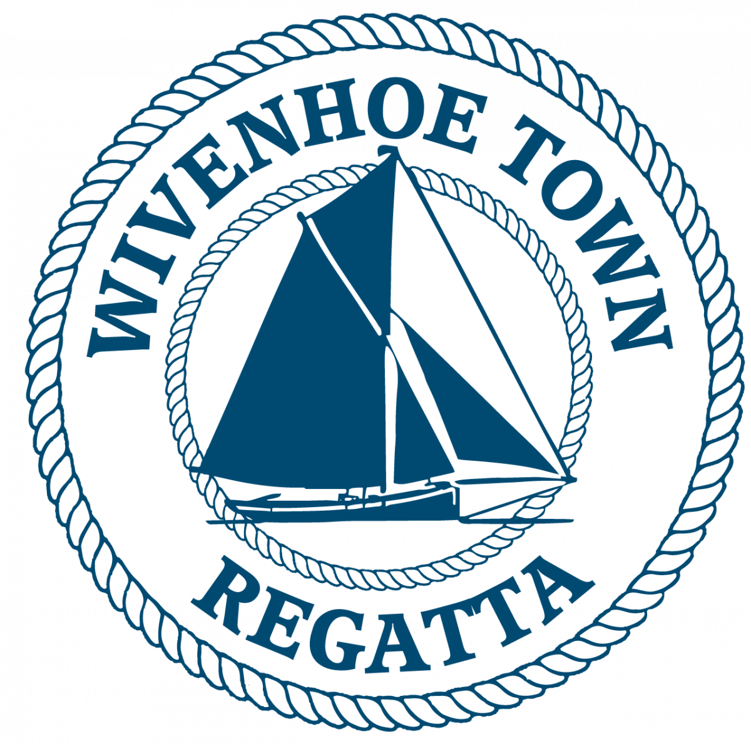
CLASSIC YACHT & GAFFERS RACE
SATURDAY 12th July 2025
HW WIVENHOE 1420 BST

The race for Classic Yachts & Gaffers will start off Batemans Tower at 1145 and finish at Wivenhoe at 1330 pm approx.

START TIMES Full Batemans Tower Start Schedule:
10.45 Smacks
11.05 Modern Yachts
11.25 Classic Yachts and Gaffers
11.45 BODs
Each Race will have its own start sequence and course number displayed before its start. Note: No vessels will be timed in after 1430.

RACE OFFICER
The Race Officers will work from Batemans Tower. They will listen out on VHF 77 from 1015 and the race course will be announced on VHF 77 at 1125. The course number will also be displayed on a board at Batemans at 1110.
The race officer may be contacted before the start on VHF channel 77.

The race shall be governed by the current version of the World Sailing Racing Rules of Sailing (RRS)

N.B. Interaction between vessels in different races in the Regatta shall be governed by the International Regulations for the Prevention of Collisions at Sea. It is strongly recommended that crews of smaller and more manoeuvrable vessels do not impede the passage of the Sailing Smacks and larger yachts.

INSURANCE
Each participating boat shall be insured with valid third party liability insurance with a minimum cover of £2,000,000 per event or the equivalent.

START LINE
Between Batemans Tower & the triangular metes on the E Mersea shore.

STARTING SEQUENCE: 5 minutes: Horn + Code flag C 
4 minutes: Horn + Blue Peter
1 minute : Long horn + Blue peter lowered
START: Horn + Code flag C lowered

If a vessel is over the line at the start a second horn will sound and one flag will be raised and stay hoisted until that offender has re-crossed the line.

COURSES FOR Classic Yachts and Gaffers SUITABLE WINDS

All courses now combined with the upstream race obeying all navigate marks along the river from Buoy No 22 to Wivenhoe

1. Bar- S, BH- S, IBH- P, No12- P, No 8- S, Finish………...(13 NM) NW-SW, NE-SE. F3-4

2. No 8- S, No12- S, No 8- S, Finish……………………..…(7 NM) Light Airs

3. IBH- S, No12- P, No 8- S, Finish………………………...(9 NM) Nly. F2-3

4. IBH- S, No19- S, IBH- S, Finish……………………........(14 NM) W-SW, E-SE. F4-5

5. BH- P, Bar- P, IBH- P, BH- S, Finish………………………(12 NM) anything but N or E. F3-5

6. A course announced on VHF Ch. 77

FINISH
A line across the river from the old hard hut 300 metres upstream of the Barrier.

Please be aware that the Smacks Modern Yachts & BODs may also be racing through the Barrier to finish at the Old WSC line 300 yards beyond it. There may also be dinghy & Gig races still in progress.

HANDICAP SYSTEM
The handicap system used will be that used by CYC or the RYA Portsmouth yardstick System or that issued by Byron software.

MOORINGS
Please pick up a free mooring if available, there may also be space on the pontoons at the new WSC club house. There will be a blue launch named Viking available to help and to ferry crews.

PRIZEGIVING AND SHORE EVENTS
Prizegiving will be held in front of the old hard hut as soon as possible after the sailing race programme has ended at 1330 approximately. Timings to be confirmed on the day.
Crew tokens will be available from the old sailing club hut on the old hard for a free pint from the old sailing club hut on the old hard and a burger from the burger stall by the British Legion after the race.

ENTRIES
Entry Forms are available on the Wivenhoe Town Regatta Website or ring 07967 505854 or email berniehetherington@gmail.com
Very late entries may be accepted via VHF 77 on the day by the Race Officer before 1030

PLEASE SPREAD THE WORD!
HAVE A CRACKING SAIL AND ENJOY THE DAY.

The race entry fee is £10 per vessel including a burger ‘n’ beer for crews

Profits from the Regatta will go to Local Charities & Community Groups

Free berths alongside West Quay or moorings in the river will be available and it's hoped that many racing craft will stay for the afternoon.

Please use BACS to transfer the £10 to the account below. Or pay on the day at the old sailing club hut.
Wivenhoe Town Regatta
Sort code – 60-06-06
Account number – 32429592

For further details before the day email berniehetherington@gmail.com or telephone 07967505854.

By returning a completed printed or emailed entry form you are agreeing to abide by the sailing and race entry instructions.
Please return your completed entry form by email to berniehetherington@gmail.com

CLASSIC YACHT & GAFFER RACE ENTRY FORM

By signing the entry form entrants also confirm that they have read the statement below and will abide by those terms and conditions-:

1. Skippers/competitors/entrants joining a regatta race indicate that they accept full responsibility for the decision to race, and that the Wivenhoe Town Regatta Committee is not responsible for injury to crew or others, nor damage to their vessel or others’ vessels, resulting from taking part.
2.They confirm that they have valid third-party liability insurance of not less than £2m.
3. The skipper accepts that it is their responsibility to ensure the safety of the crew, and that the crew is provided with lifejackets and other appropriate safety equipment.
4. Skippers must be aware of the Racing Rules of Sailing which, in the event of a dispute between competitors during the race, will be interpreted in the spirit of Regatta Racing.
5. Skippers are reminded that when in the vicinity of any vessels not competing in their race, the International Rules for the Prevention of Collisions at Sea will apply.

Yacht name: Class:

LOA: LWL: Beam: Draft:

Sail No: Handicap No: Keel Type: (e.g. long, fin, bilge, lifting etc)

Hull colour: Sail Colour: Rig:

Owners Name: Number of Crew onboard

Address: Mobile tel no:

Email address:

Information of Interest for Regatta commentator

Signed Print Name

