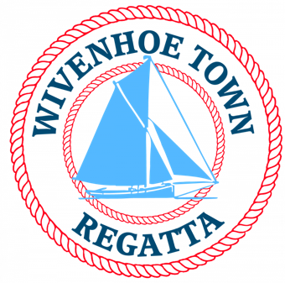
WIVENHOE TOWN REGATTA GIG RACING

SATURDAY 4th JULY 2026

HW WIVENHOE 1554 BST

ALL TIMES ARE PROVISIONAL

THE JOHN STEWART MEMORIAL GIG RACE – 3 nautical miles

A handicap time trial on a tidal course starting from Wivenhoe from 14.00, finishing back at Wivenhoe at approximately 15.15-15.30.

ELIGIBILITY

The race is open to all coxed traditional fixed seat boats recognised by the Great River Race, with a handicap being used to determine the starting order and to correct the final results. Crews to consist of a cox and rowers, with a minimum of rowers 50% being female.

START TIMES

The race will start and finish from the OLD Wivenhoe Sailing Club line at the Old Hard - a line across the river at the WSC Old Hut and Hard, approximately 300 yards upstream of the Barrier.

Please note the same line will be used for the WODs and handicap dinghies - start times will be available before the event. The river may be very busy and certain vessels (such as smacks) have limited maneuverability and should be given space.

The starting order will be issued over the radio prior to the starting sequence and will based on handicap with the slowest boats (plus alphabetical based on the names) starting first, beginning at 14.00 for the first gig and continuing at 1-minute intervals for remaining gigs.

RACE OFFICER
The Race Officers will work from WSC Hut on the Old Hard. They will listen out on VHF 77 from 13.50.

START SEQUENCE

5 minute warning Ch.77 & Horn
2 minute warning Ch.77 & Horn
1 minute warning Ch.77 & Horn
10 second count down over the radio & Horn for the start. (Then repeating for subsequent gigs at 1-minute intervals)

Penalties for over the line: part boat 1 min or taking 360’ turn (within sight & radio of start, but without impeding any other boats); 5 min penalty for a whole boat length over.

COURSE

Start > (Red) Navigation Buoy No. 22 to Port > Finish

See Chart below. Navigation buoy No. 22, which must be left to port, is located off the Fingringhoe Wick Nature Reserve. There is no requirement to observe any other channel markers.

Note: there will NOT be a laid buoy marking 4-boat lengths to the mark – coxes should estimate this themselves and establish rights at the turning zone through clear communication with other gigs.

FINISH
Line across the river at the WSC Old Hut and Hard 300 yards beyond the Barrier (see map below). Continue upriver to clear the finish area and then look for a mooring or come ashore along West Quay (see Moorings below).

RULES
Mixed crews only (50% minimum being female). Class rules and the HYGA racing rules (available from: https://harkersyardrowers.teamapp.com/documents) to be adhered to. Lifejackets to be carried for all onboard, and worn by the cox at all times. Collision Regs and Rules of the Road to apply, so gigs must give way to sail.

BRIEFING
The Briefing will be made over VHF 77 at 13.50 hrs on 4 July. All boats to follow instructions and rules as set out in this Notice of Race, unless superseded at the briefing. Any questions should be directed to the Race Officer on the day prior to the start sequence, or to the contact details below before the event.

****SPRINT RACING****

This year, in addition to the John Stewart Race, all gigs are invited to take part in a knockout sprint race series. The first start time will be 1600 hrs. Races will be approximately 250 yards – starting from the Town Jetty and finishing at WSC Old Hut.

A briefing will be made over VHF 77 at 15.50 hrs on 4 July.

LAUNCHING
Visiting gigs are able to launch at the Wivenhoe Sailing Club on the day, subject to prior arrangement and confirmation. Please request this at the time of entry and at least 7 days prior to the date of the race. For larger gigs, launching in Brightlingsea from the public hard is preferred – allow 1.5 hrs to row up to Wivenhoe. If using a delivery crew, you can swap crews at the WSC pontoon immediately before the tidal barrier – contact the race organisers for the access code.

MOORINGS AT WIVENHOE AFTER THE RACE
A rope pilot ladder should be in position along West Quay, enabling you to offload crews and moor gigs along the sea wall. Note: Care must be taken and doing so is entirely at your own risk. Alternatively, gigs can pick up any available mooring, and the Wivenhoe Sailing Club launch “Viking” should be available to ferry crews ashore. The orange WSC Safety Boat will be standing by, but will be engaged only in safety monitoring.

PRIZEGIVING AND SHORE EVENTS
Numerous activities and stalls running throughout the afternoon – encourage your friends, family and fellow club members to attend. See Regatta Programme once ashore (or check https://wivenhoeregatta.co.uk/) for details and prizegiving times.

MAP

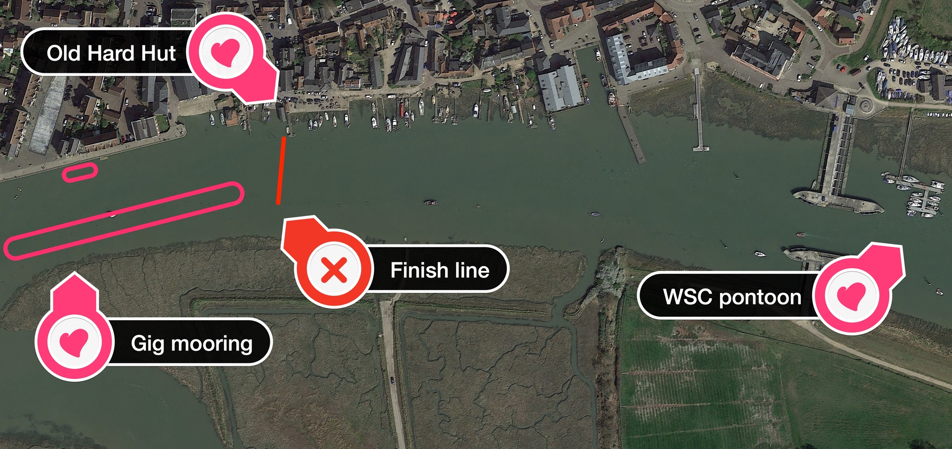

START &

HEADING HOME
Any crew swaps or departure preparations (e.g. towing) can be done on the WSC pontoon downstream of the barrier.

CHART
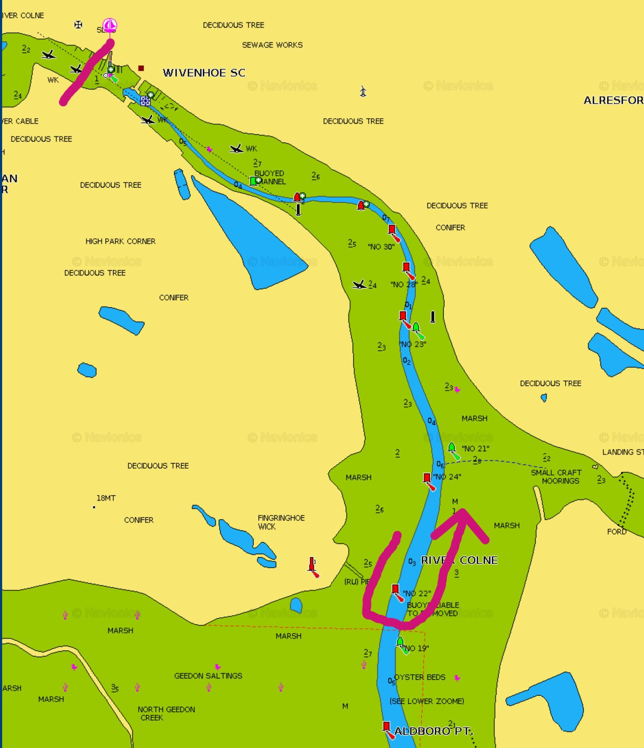

WIVENHOE TOWN REGATTA
TRADITIONAL FIXED SEAT ROWING RACE

SATURDAY 4 July 2026 HW WIVENHOE 1554 BST

REGISTRATION FORM

The race entry fee is £5 per gig
(to include entry to sprint races)

Please use BACS to transfer the £5 to the account below. Or pay on the day at the old sailing club hut.
Wivenhoe Town Regatta
Sort code – 60-06-06
Account number – 32429592

To register, please complete and email this form back to wivenhoecorsairs@gmail.com by 26 June 2026

Gig name:

Gig type:

Hull Colour:

Club Name:

Emergency contact number on day:

Entry to John Stewart Race: Yes/No

Entry to knock out sprint races: Yes/No

By completing and returning this is registration from, you are confirming that you have current third party marine insurance cover for not less than £2,000,000.

Disclaimer of Liability: Competitors are entirely responsible for their own safety, whether afloat or ashore, and nothing reduces this responsibility. It is for the competitors to decide whether their boat is fit to row in the conditions in which it will find itself. By launching or going to sea competitors confirm the boat is fit for those conditions and they are competent to compete in them. Nothing done by the organisers can reduce the responsibility of the owners and/or competitors, nor will it make the organisers responsible for any loss, damage, death or personal injury, however it may have occurred, as a result of the boat taking part in the racing. The provision of safety boats does not relieve owners and competitors of their responsibilities.

For any questions please about this Race Notice, please email Danielle Southey via wivenhoecorsairs@gmail.com

LATE ENTRIES (after 26 June 2026)
(a) May be accepted by email wivenhoecorsairs@gmail.com
(b) Very late entries may be accepted at the discretion of the Race Officer via VHF on the day before 1400.

